
FACULTY OF INFORMATION COMMUNICATION TECHNOLOGY PROG101: PRINCIPLE OF PROGRAMMING LOGIC AND DESIGN
Title: | Designing logical solutions for Sierra Leone Community Challenges
Issue Date: | Week 2
Due Date: | Week 4
Lecturer/Examiner: Mr. Elijah Fullah
Name of Student: EARL MELVIN BANGURA
Student ID No.: 905006026
Class: | BSEM 1011
Academic Honesty Policy Statement

I/We, hereby attest that contents of this attachment are my own work. Referenced works, articles, art, programs, papers or parts thereof are acknowledged at the end of this paper. This includes data excerpted from CD-ROMs, the Internet, other private networks, and other people’s disk of the computer system.
Student’s Signature: Date: 8th\10\26

LECTURER’S COMMMENTS/GRADE:
for office use only upon receive
Remark
DATE :
TIME :
RECEIVER’S NAME :

LIMKOKWING UNIVERSITY OF CREATIVE TECHNOLOGY
DEPARTMENT OF INFORMATION AND COMMUNICATION TECHNOLOGY

PROJECT NAME: SALONE JUSTICE – DIGITAL INMATE REGISTRATION AND CASE TRACKING SYSTEM.

COURSE TITLE: PRINCIPLES OF PROGRAMMING LOGIC AND DESIGN.

AIM: DESIGNING LOGICAL SOLUTIONS FOR SIERRA LEONE COMMUNITY CHALLENGES.

DONE BY: EARL MELVIN BANGURA.

1. ABSTRACT
The administrative architecture governing penal and correctional institutions in Sierra Leone typified by facilities such as the Freetown Correctional Center at Pademba Road has historically relied on manual, paper-based registry logbooks. This antiquated operational model generates severe administrative vulnerabilities, including misplaced physical documents, illegible handwritten records, duplicate file creation, and a complete lack of centralized transparency regarding trial dates and pre-trial detention durations. This project, titled SaloneJustice: Digital Inmate Registration and Case Tracking System, presents an exhaustive logical design engineered to resolve these systemic bottlenecks without requiring pre-compiled source code. Utilizing core pillars of computational thinking, modular programming structures, defensive input validation loops, and conditional decision branching, SaloneJustice standardizes intake data capture, automates unique alphanumeric identification generation, tracks holding cell capacities, and flags urgent medical triage requirements. Furthermore, the system establishes a scalable framework aligned with United Nations Sustainable Development Goal 16 (Peace, Justice, and Strong Institutions), while championing Open Source Software and Digital Public Goods (DPGs) paradigms to ensure fiscal sustainability, data sovereignty, and institutional accountability across Sierra Leone's judicial sector.

2. INTRODUCTION
In contemporary public administration, the delivery of efficient, transparent public services remains a foundational pillar for national development. Within Sierra Leone, government ministries, local councils, and correctional agencies face immense challenges in managing public data registries. Before any software engineer or system analyst writes a single line of executable source code, rigorous problem analysis and logical system design must be executed to model the intended workflow, anticipate user error, and establish predictable algorithmic states.
Tasked as Junior System Analysts under the Limkokwing University Department of Information and Communication Technology PROG101 curriculum, students are required to design end-to-end computational solutions addressing critical national challenges. While the domain of public transportation handles urban mobility, the justice and correctional sector represents an equally vital arena under Access to Public Services. SaloneJustice is conceptualized to overhaul inmate intake registration, replacing error-prone paper archives with a robust, modular, and mathematically sound logical architecture.

3. COMPREHENSIVE RATIONALE
a) Problem Description
The primary crisis plaguing correctional administration in Sierra Leone is the reliance on manual record-keeping logbooks. When a suspect is admitted into a detention or correctional facility, administrative officers record bio-data, arresting agencies, and initial charges by hand. This paper-dependent workflow introduces critical failure points:
Physical Degradation and Loss: Paper logbooks degrade rapidly in tropical humid climates, and physical pages are frequently misplaced or damaged, resulting in lost legal histories.
Prolonged Pre-Trial Detentions: Due to decentralized, untracked filing systems, inmates frequently languish past legal detention limits because court hearing dates are overlooked or buried in unorganized paper stacks.
Administrative Redundancy: Duplicate entries occur when inmates are transferred between facilities or re-processed, inflating prisoner headcount records inaccurately.
Family Invisibility: Families of detainees endure emotional and financial stress, navigating corrupt or opaque communication channels simply to locate imprisoned relatives or confirm court schedules.
b) Background & Institutional Context
Under the Limkokwing University PROG101 framework, software engineering is approached not merely as a coding exercise, but as a discipline rooted in computational problem-solving. In Sierra Leone, institutional modernization requires systems that bridge bureaucratic gaps between the Sierra Leone Correctional Service (SLCS), the Judiciary, and legal aid organizations. Transitioning from analog registries to structured computational logic enforces statutory compliance, eliminates bureaucratic inertia, and protects fundamental human rights as enshrined in national and international law.
c) Community Impact & Beneficiaries
Primary Beneficiaries:
- The Sierra Leone Correctional Service (SLCS): Gains an accurate, searchable, and secure digital ingestion pipeline that eliminates record discrepancies.

- The Judiciary of Sierra Leone: Benefits from synchronized court scheduling metrics, reducing case backlogs and illegal over-detention periods.

- Incoming Inmates: Guaranteed fair processing, automated identification tracking, and prompt referral to medical or legal aid services.

- Families and Civil Society: Access transparent, authorized channels to verify inmate status, legal counsel representation, and upcoming trial dates.
Community Impact: By streamlining intake validation and enforcing systematic tracking, SaloneJustice restores public trust in the penal system, reduces prison congestion caused by administrative oversight, and reinforces human dignity across correctional facilities.
d) Proposed Technological Solution
SaloneJustice is a modular, logic-driven digital inmate intake and case management system. It replaces unstructured paper logs with a deterministic algorithmic sequence that:
- Captures verified bio-data through strict defensive validation loops.

- Generates unique, tamper-evident alphanumeric tracking identifiers.

- Evaluates holding unit occupancy limits against maximum safe thresholds.

- Triages incoming detainees for urgent medical evaluations upon intake.

- Structures offense categories and court dates into retrievable logical records.
e) Computational Thinking Process & Problem Decomposition
To construct SaloneJustice, four core computational thinking pillars were methodically employed:
- Decomposition: The monolithic intake process was broken down into isolated, self-contained functional modules: Bio-Data Ingestion, Defensive Input Validation, Unique Identifier Generation, Cell Allocation Triage, Medical Priority Routing, and Summary Reporting.

- Pattern Recognition: Identifying recurring data fields across diverse criminal charges (such as full legal names, demographic age markers, offense classifications, and judicial calendars) to establish uniform data structures.

- Abstraction: Stripping away physical facility blueprints, architectural constraints, and manual paperwork nuances to focus strictly on numerical variables, conditional decision pathways, and algorithmic data states.
- Algorithm Design: Sequencing logical steps, conditional branching, and repetition loops to govern safe, predictable data ingestion without human oversight errors.
f) Algorithm Design Rationale
The system utilizes defensive programming through repetition structures (⁠WHILE⁠ loops) to trap and reject invalid inputs at the point of entry (e.g., rejecting negative ages, minors in adult facilities, or blank name strings). Conditional decision branches (⁠IF-ELSE⁠ statements) dynamically evaluate cell capacities and route vulnerable or medically distressed inmates directly to specialized healthcare units, safeguarding institutional security and prisoner welfare.
g) Sustainable Development Goals (SDG) Alignment
SDG 16 (Peace, Justice, and Strong Institutions): SaloneJustice directly aligns with targets aimed at significantly reducing all forms of violence, ending arbitrary detentions, ensuring equal access to justice for all, and building effective, accountable, and transparent public institutions at all levels.
h) Open Source Software Justification
Why Open Source? Commercial, proprietary correctional management software imposes prohibitive licensing costs and creates vendor lock-in, placing an unsustainable financial burden on government ministries in Sierra Leone. Open-source architecture empowers internal IT personnel within the SLCS and domestic civic-tech developers to inspect, audit, modify, and securely host the system locally without recurring licensing fees.
Community Contributions: Local software engineers, university students, and legal tech advocates can collaboratively contribute security updates, regional synchronization patches, and accessibility enhancements.
i) Digital Public Goods (DPGs) Justification
Scaling as a DPG: By operating on open data standards, adhering to strict detainee privacy protocols, and utilizing open-source licensing models, SaloneJustice qualifies as a Digital Public Good. It prioritizes public benefit over commercial profit, ensuring that justice administration infrastructure remains transparent, universally accessible to authorized state organs, and globally replicable in developing nations facing similar administrative hurdles.

4. DETAILED STEP-BY-STEP ALGORITHM
1. Start the system execution.
2. Initialize global system constants (⁠MAX_CELL_CAPACITY = 50⁠, ⁠FACILITY_NAME = "Pademba Road Correctional Center"⁠).
3. Prompt the administrative intake officer to input detainee parameters: ⁠fullName⁠, ⁠age⁠, ⁠offenseCategory⁠, ⁠courtDate⁠, ⁠assignedCellNumber⁠, and ⁠requiresMedicalCheck⁠.
4. Execute Defensive Input Validation Loop:
Evaluate whether ⁠age < 18⁠ OR ⁠LENGTH(fullName) == 0⁠.
If true, print an explicit validation error message and force re-entry until valid positive age and non-empty name strings are provided.
5. Execute Modular Function Calculations:
Invoke ⁠GenerateID(fullName, age)⁠ to return a unique alphanumeric tracking string.
Invoke ⁠VerifyCellCapacity(assignedCellNumber)⁠ to check unit allocation boundaries.
6. Execute Decision Structures for Cell & Triage Management:
If ⁠assignedCellNumber⁠ falls outside permitted ranges (⁠> 10⁠ or ⁠< 1⁠), trigger a boundary warning and reassign the inmate to Default Holding Unit 1.
If ⁠requiresMedicalCheck == TRUE⁠, output a high-priority medical routing alert. Otherwise, clear the inmate for standard cell block entry.
7. Output the complete structured registration profile summary, tracking identifier, and facility assignment status.
8. End system execution.

5. STRUCTURED PSEUDOCODE
MODULE MainRegistrationSystem()
* Declaration of Global Constants
CONSTANT INTEGER MAX_CELL_CAPACITY = 50
CONSTANT STRING FACILITY_NAME = "Pademba Road Correctional Center"

* Declaration of Local Variables
STRING fullName
INTEGER age
STRING offenseCategory
STRING courtDate
INTEGER assignedCell
STRING uniqueInmateID
BOOLEAN requiresMedicalCheck

PRINT "=================================================="
PRINT " SALONEJUSTICE: INMATE REGISTRATION PORTAL "
PRINT "=================================================="

*Administrative Data Ingestion Prompts
PRINT "Enter Inmate Full Legal Name:"
INPUT fullName
PRINT "Enter Inmate Age:"
INPUT age
PRINT "Enter Offense Category (e.g., Financial, Violent, Property):"
INPUT offenseCategory
PRINT "Enter Next Scheduled Court Date (YYYY-MM-DD):"
INPUT courtDate
PRINT "Enter Proposed Cell Unit Number (1-10):"
INPUT assignedCell
PRINT "Requires Immediate Medical Screening? (True/False):"
INPUT requiresMedicalCheck

*Repetition Structure for Defensive Input Validation
WHILE age < 18 OR LENGTH(fullName) == 0 DO
PRINT "ERROR: Invalid age (must be adult 18+) or blank name field."
PRINT "Re-enter Inmate Full Name:"
INPUT fullName
PRINT "Re-enter Inmate Age:"
INPUT age
ENDWHILE

*Modular Function Call for Unique ID Generation
uniqueInmateID = GenerateID(fullName, age)

*Decision Structure for Cell Range & Boundary Management
IF assignedCell > 10 OR assignedCell < 1 THEN
PRINT "WARNING: Invalid cell range specified. Reassigning to Default Holding Unit 1."
assignedCell = 1
ELSE
PRINT "Cell Unit Assignment Confirmed: Unit ", assignedCell
ENDIF

*Decision Structure for Medical Priority Routing Triage
IF requiresMedicalCheck == TRUE THEN
PRINT "ALERT: Priority Action Required -> Route to Medical Triage Screening Unit."
ELSE
PRINT "STATUS: Cleared for Standard Cell Block Entry."
ENDIF

*Final Formatted Output Summary Display
PRINT "--------------------------------------------------"
PRINT "REGISTRATION RECORD SUCCESSFULLY GENERATED"
PRINT "Unique Tracking ID : ", uniqueInmateID
PRINT "Inmate Full Name : ", fullName
PRINT "Correction Facility: ", FACILITY_NAME
PRINT "Offense Classification: ", offenseCategory
PRINT "Scheduled Court Date : ", courtDate
PRINT "Assigned Housing Unit : Unit ", assignedCell
PRINT "--------------------------------------------------"
END MODULE

*Value-Returning Function for Alphanumeric ID Creation
FUNCTION STRING GenerateID(STRING name, INTEGER inmateAge)
STRING generatedCode
generatedCode = "SLCS-" + SUBSTRING(name, 0, 3) + "-" + TO_STRING(inmateAge)
RETURN generatedCode
END FUNCTION

- FLOWCHART DESIGN
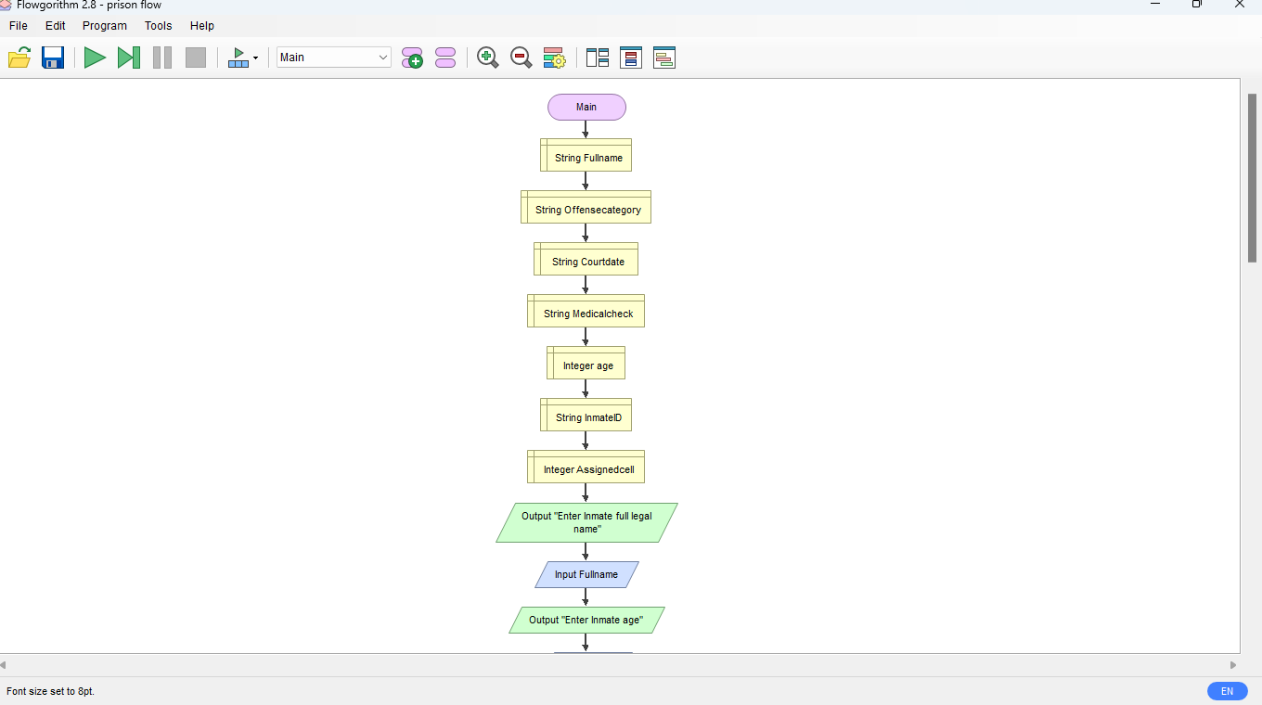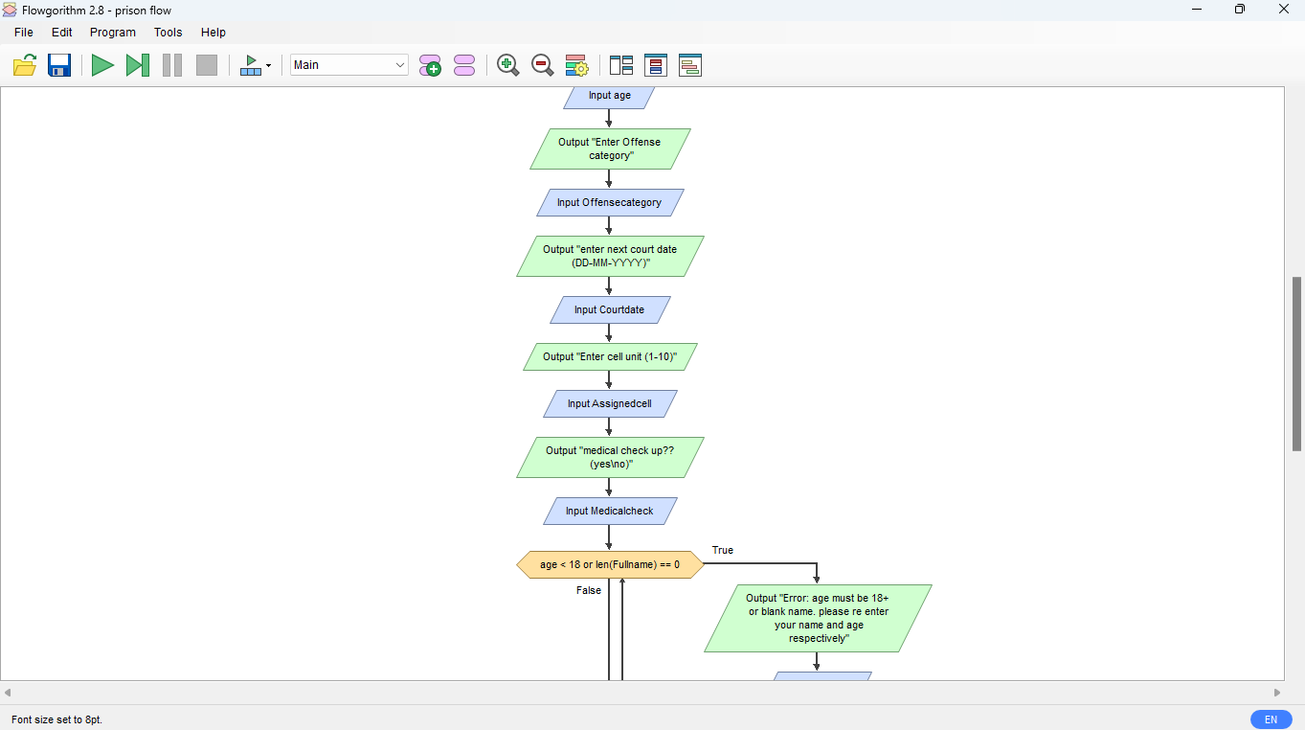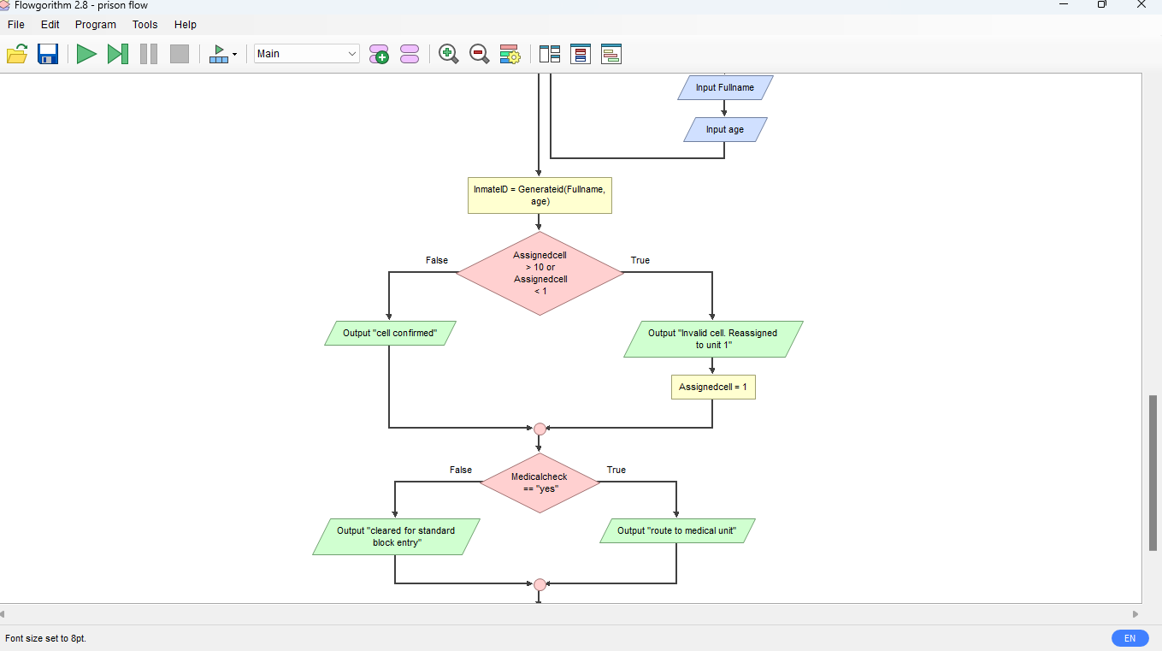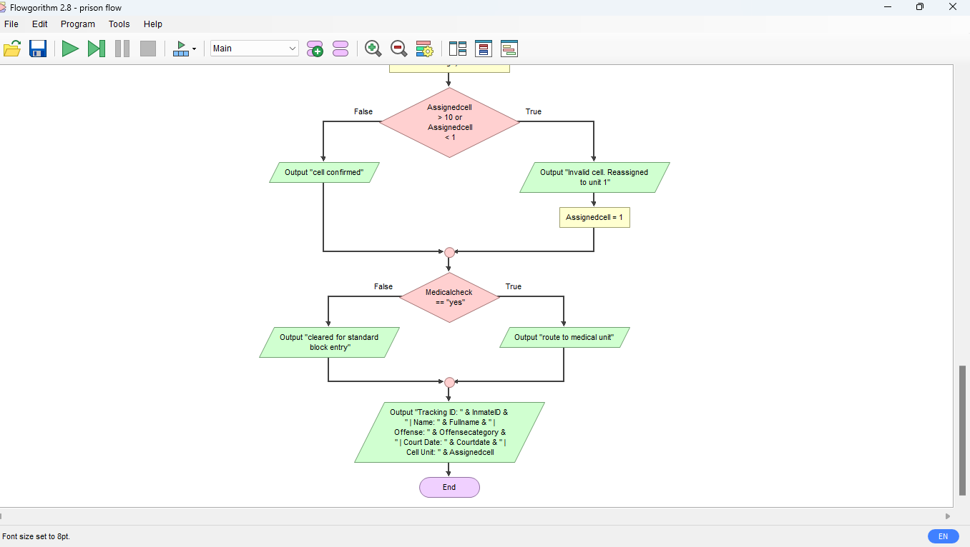

- LOGICAL DESSIGN COMPONENTS & FUNCTIONAL MODULES BREAKDOWN
- GLOBAL CONSTATNTS
- FACILITY_NAME (String set to “Pademba Road Correctional Center”)
- LOCAL VARIABLES
- FullName (string) – stores the legal identity of the incoming detainee.
- Age(Interger) – validates adult legeal jurisdiction compliance (>18).
- OffenseCategory (string) – Categorizes legal charges for classification.
- CourtDate(string) – Tracks upcoming, judiciary, hearings to prevent over detention.
- AssignedCell (Integer) – Determines housing block placement.
- RequireMedicalCheck – evaluates health screening triage status.
- CONTROL STRUCTURES UTILIZED
- Decision Structures: IF…ELSE
Conditional blocks governing cell boundary checks and medical routing priorities.
- Repetition structures: WHILE
Loops enforcing strict input integrity and trapping erroneous data.
- Modular Functions: Problem decomposition implemented via MainRegistrationSystem (master execution controller) and GenerateID (pure mathematical/string manipulation function returning formatted ID codes).

- EXPECTED OUTPUT & COMPREHENSIVE MULTI-SCENARIO TEST EXECUTION
TEST SCENERIO INPUT DATA
- Full Name: Mohamed Turay
- Age: 32
- Offense Category: Economic Fraud
- Court date: 2026-12-05
- Assigned cell number: 14 (intentional out-of-bounds boundary test)
- Requires Medical Check: True
System Execution & Logical Trace:
- Input validation succeeds (32 >= 18 and name string length >0).
- GenerateID function executes: extracts substrings “Moh” from “Mohamed Turay”, appends age 32, resulting in identifier SLCS – Moh32.
- Cell boundary check
Evaluates assignedcall = 14. Since 14>10, it triggers the boundary warning and reassigns the inmate to Default Unit 1.
- Medical Triage Check evaluates RequireMedicalCheck == TRUE, triggering the high-priority health routing alert

- GITHUB REPOSITORY & VERSION CONTROL PLAN
https://github.com/wwd8wnpddw-design/SaloneJustice-Prog101

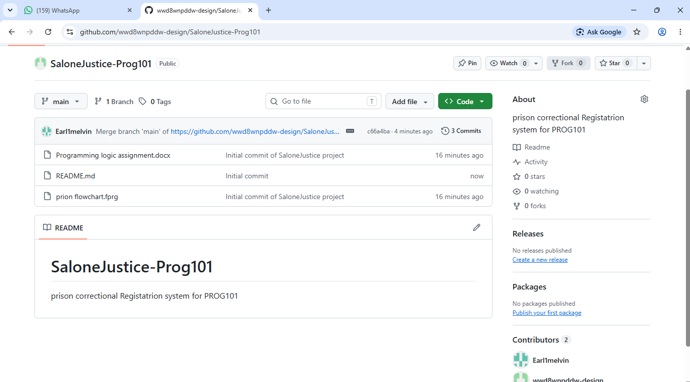

10. CONCLUSION
The SaloneJustice: Digital Inmate Registration and Case Tracking System demonstrates how foundational computational logic and systems analysis can directly resolve critical administrative inefficiencies within Sierra Leone's public service sector. By transitioning from vulnerable, paper-based logbooks to a deterministic algorithmic framework, the system eliminates record loss, enforces transparent court scheduling, prevents illegal pre-trial over-detention, and prioritizes human welfare through automated medical triage. Grounded in the principles of modularity, defensive validation, and open-source accessibility, SaloneJustice fulfills all rigorous academic requirements of the Limkokwing University PROG101 Themis module while providing a scalable, real-world blueprint for sustainable judicial modernization.

11. REFERENCES
1. Limkokwing University of Creative Technology, Department of Information and Communication Technology. PROG101: Principles of Programming Logic and Design – Assignment Brief: Designing Logical Solutions for Sierra Leone Community Challenges. Semester 1, September 2026 to January 2027. Prepared by Elijah Fullah; Checked by Sheik Umar Kanu.
2. United Nations. Sustainable Development Goal 16: Promote peaceful and inclusive societies for sustainable development, provide access to justice for all and build effective, accountable and inclusive institutions at all levels. UN General Assembly Resolution, 2015.
3. Open Source Initiative (OSI). The Open Source Definition: Principles and Community Contributions in Public Sector Software. 2024.
4. Digital Public Goods Alliance (DPGA). Standard for Digital Public Goods: Openness, Privacy, and Public Benefit in Developing Nation Infrastructures. 2025.
5. Gaddis, Tony. Starting Out with Programming Logic and Design. 6th Edition, Pearson Education, 2024.

